PROJECT REPORT

Book Recommender System

Name : Marale Suraj
Technology : Python, Streamlit, Machine Learning
Date : 20-06-2026

1. Introduction
In today's digital world, choosing the right book from thousands of available options can be challenging. A Book Recommender System helps users discover books based on their interests.
This project uses Machine Learning and Python to recommend books similar to a user's selected book. The system provides personalized suggestions, making it easier and faster for readers to find books they may enjoy.

2. Objectives of the Project
The primary objective of this project is to develop a recommendation system that suggests books based on user interests and similarity analysis.

Specific Objectives:
- To recommend books similar to a selected book.
- To improve user experience through personalized suggestions.
- To display popular books with ratings and reviews.
- To provide a simple and user-friendly web interface.

Problem Statement
When users search for books, they often find too many options and get confused about which book to choose. It is difficult to manually search through thousands of books.
This project solves that problem by automatically recommending similar books based on ratings and user preferences.

Dataset Used
The project uses three datasets:

Books Dataset
Contains:
- Book Title
- Author Name
- Publisher
- Book Image URL

Ratings Dataset
Contains:
- User ID
- Book ISBN
- Rating

Users Dataset
Contains:
- User ID
- User Location
- User Age

Working of the Project

Step 1: Data Collection
Book, rating, and user datasets are collected.

Step 2: Data Cleaning
Unnecessary and missing data are removed.

Step 3: Data Processing
A user-book rating table is created using Pandas.

Step 4: Similarity Calculation
Machine Learning calculates similarity between books using user ratings.

Step 5: Recommendation
When a user enters a book name, the system finds similar books and displays recommendations.

System Architecture
User Selects Book
↓
System Searches Book
↓
Similarity Scores Checked
↓
Recommendation Engine Works
↓
Recommended Books Displayed

Technologies Used

Frontend
- Streamlit

Backend
- Python

Libraries
- Pandas
- NumPy
- Pickle
- Streamlit

Features
- Easy-to-use interface
- Fast recommendations
- Displays book covers
- Shows author names
- Recommends similar books

Advantages
- Saves time for readers
- Helps discover new books
- Provides personalized suggestions
- Simple and user-friendly
- Works efficiently on large datasets

Book Recommender System Output Screen

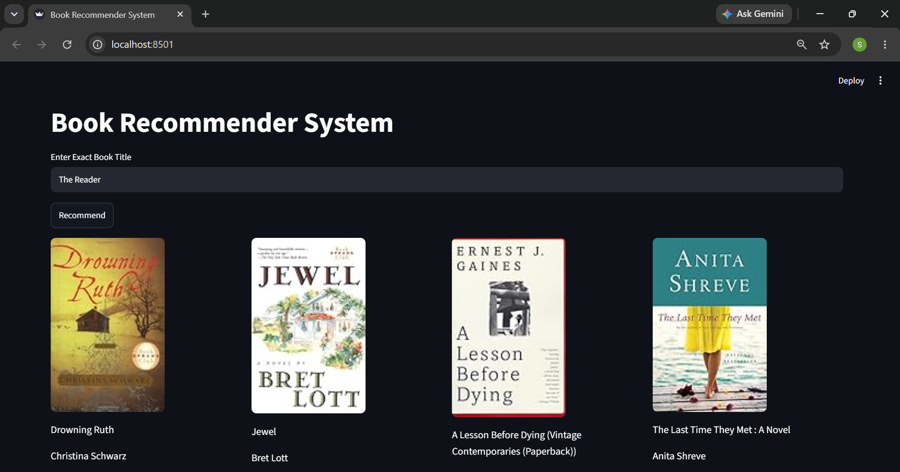

Conclusion
The Book Recommender System is a useful machine learning application that helps users find books according to their interests. By analyzing user ratings and book similarities, the system provides accurate recommendations and improves the overall reading experience.

